Page 7 TROPIC LIGHTNING NEWS April 20, 1970

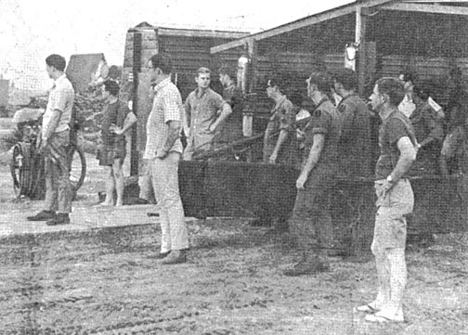
IT MAY BE “after hours,” but men from the hospital staff are on the job as they wait with hospital litters for a dustoff helicopter that is about to land.

Speed, Skill and Care a Must At Tropic Lightning’s MUST
By 1LT ROBERT E. GOLDEN
TAY NINH - “MAS-CAL!” With this word, people at the 25th Division’s 45th Surgical Hospital begin to move.
On a recent Sunday night when the call was sounded doctors and nurses converged on the pre-op (pre-operative) ward and prepared all the equipment they would need. Everyone else headed towards the breezeway in front to man the litters when the dust-off choppers, bearing 15 casualties, came in.
The 45th Surg is a “MUST” facility. MUST means Medical Unit , Self-contained, Transportable - in other words, a portable hospital.
The “heart” of the hospital consists of five large inflatable “bubbles”, six expandable steel buildings (each one is about three times the size of a conex) and five utility packs that provide all the air conditioning, heat, water and power for the entire hospital.
The MUST hospital is a new concept and has replaced the MASH concept (Military Army Surgical Hospital). The 45th Surg, now commanded by Lieutenant Colonel George M. Pomerants, opened in November 1966, and was the first MUST-type hospital in Vietnam.
As in any other hospital, the men and women of the 45th are on call 24 hours a day. It has to be that way, since most of the “crises” occur after normal duty hours.
“We usually have our MASCALS between 1800 and 1900 hours or between five and seven in the morning,” said Major John J. Candelaria, hospital Executive Officer.
When dustoff ships arrive at the hospital’s chopper pad, patients are hurried into the preop ward for immediate emergency treatment. In the process known as `triage’ (French for `to separate’), all wounded soldiers are categorized as a team of doctors carefully examines each man and decides whether he is to remain at the hospital for treatment, whether he can be released or whether he is to be further evacuated.
Patients designated to stay are prepared for surgery in one of the three surgical suites. Patients needing further evacuation are quickly loaded onto waiting choppers that take them to either of Long Binh’s evacuation hospitals, the 25th or 93rd.
According to Captain George J. Wright, Adjutant, the MUST hospital is still in the experimental stages.
“We feel the 45th Surg serves a very important and useful purpose for the men out in the field,” Wright explained. “We’re the middle man between the medic out in the boonies and the evacuation hospitals in Cu Chi and Long Binh. There’s no doubt that we’ve saved many lives here during our existence. I think that justifies our being here.”
You might say that the best of care is a must at the 25th Division’s MUST.
SPECIALIST 5 Stanley W. Behner (center) helps lift a litter patient on to a chopper for further evacuation. | 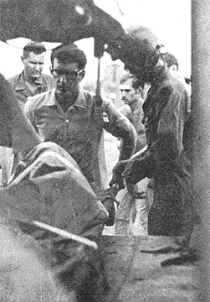
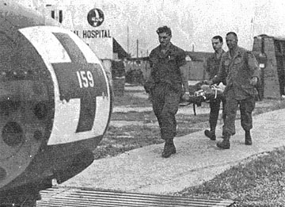 | A PATIENT, after receiving emergency life-saving treatment at the 45th Surgical hospital, is carried to a waiting Medevac chopper that will take him to an evacuation hospital in Cu Chi or Saigon.
DOCTOR (Captain) John C. Kecirns carefully prepares a wounded trooper for surgery. | 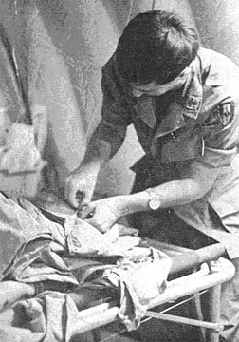
http://www.25thida.com/TLN/tln5-16.htm#v5n16p7b

